Database Systems
Belgium-campus-itversity | Class – virtual online
Assignment 2 – DBD181
Alexander Kruger - 605298
2026/07/17
Contents
Introduction 2
Strengths and Limitations of Access 2
UML Notation 2
One-to-One 3
One-to-Many 3
Many-to-Many 3
Characteristics and principles of Relational Databases 4
Emerging Data Models 5
The Future of Database Systems 6
References 7

Introduction
This research report explores different models of databases, including the popular Microsoft access, along with the basic relationships of entities, principles of relational databases and lastly the emergence of the popularity of non-relational databases. The industry is changing from using only a singular data storage technology for all needs and is instead progressing into using different tools for different needs.

Strengths and Limitations of Access
Microsoft Access is a relational database management system (RDBMS) that is included in the Microsoft 365 Office package and because of Access’ inclusion in Office, it tends to be more popular than other alternatives. According to Hennig (2010a), Access is a perfect solution to single-user applications. Hennig further expands that Access has an intuitive and simple enough design that even beginners can do their tasks effectively. This enables streamlined development of applications. Access databases are also easy to store and distribute because the database is saved in a single file (either mdb or accdb filetype). Even though Access has all these strengths, its limitations prevents it from being the de facto choice for all scenarios.
Hennig (2010b )describes that the main limitation of Access is its physical limitation of a 2GB size and the limit on concurrent users. Access has a limit of 255 simultaneous users, but in practice a limit of 20 concurrent users depending on the schema and network of your database. Additionally Balter (2002) states that the security of Access is very limited, due to network sharing forcing you to grant read-, write- and delete permissions for users. Having these permissions granted to users makes a database vulnerable to hackers or users who accidentally deletes records.
These limitations define the use case of Access since you must choose between costs and convenience, and scalability. Considering the limitations, it’s evident why Hennig proposes that Access is perfect for single-user applications. Access can be used in small businesses or stores to track stock while it may not be suited on its own if used in a supermarket with multiple tills. The key word is on its own, Access can still function as the front-end interface meanwhile the data and storage is stored in the backend with an alternative such as Microsoft SQL Server. On its own Access can be used in small single offices or even to quickly design and prototype because of its rapid development strength. However to use Access efficiently as it is a relational database, it’s important to know how to create relationships and to design entity relational diagrams (ERDs).

UML Notation
ERDs are made to map out entities with their attributes along with the relationship with other entities. UML ERDs’ are only different in that; a single entity is split up into three components called the horizontal compartments. The top compartment is the entity’s name, and the middle is the data fields / list of attributes. Meanwhile the bottom compartment is for methods or operations, but if UML is used for data modelling it is left blank, because UML was specifically intended for an Object-Oriented Programming environment. (Harrington, 2016)
In UML an entity can have a relationship type description, to indicate it is singular (1), multiple (*), or zero (0). We can also combine them, for example one or more (1..*) or, zero or more (0..*). These different symbols represent multiplicity of the relationships.
Harrington (2016) also explains that there are three different types of relationships :

One-to-One
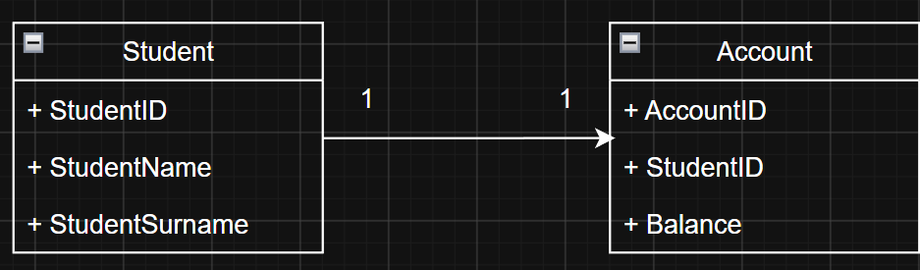
The one-to-one relationship links a single entity that relates to exactly one other entity. In this example a student only has one account, and an account only has one student associated with it.

One-to-Many
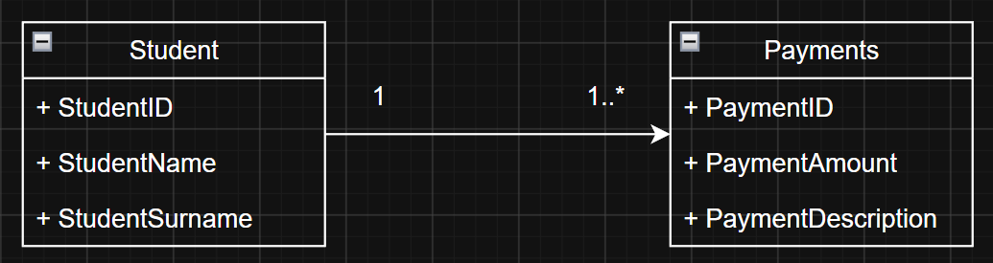
The One-to-Many relationship links a single entity to another entity, where one entity is singular and the second entity is multiple. In this example a student can make many payments, but payments are linked to only one student.

Many-to-Many
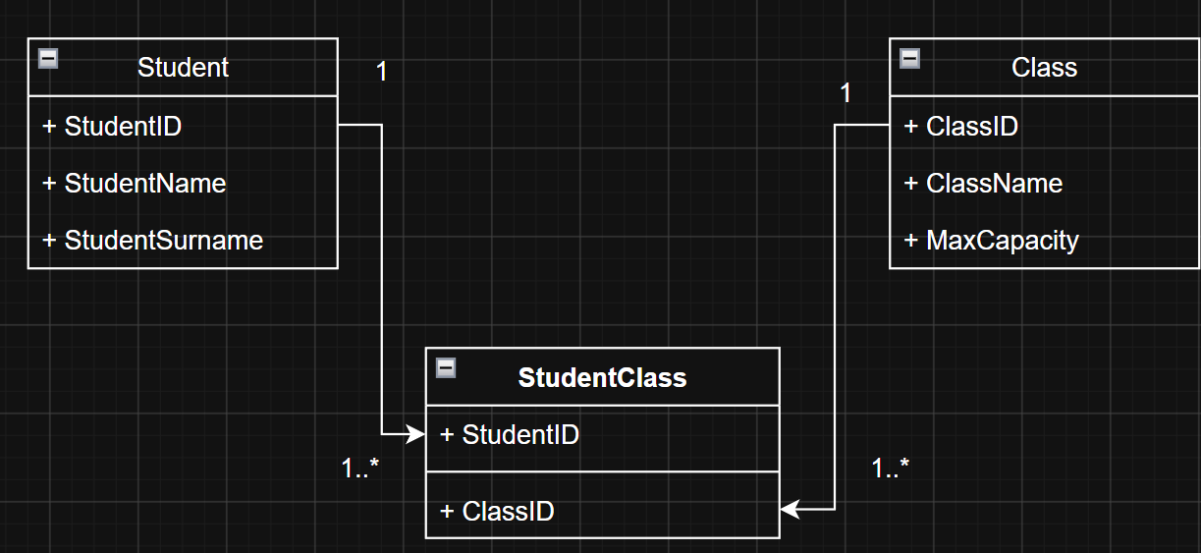
The Many-to-Many relationship links two entities that both can be related multiplicatively to each other. In the example above a student can attend many classes and classes can accommodate many students. To resolve the Many-to-Many we use a bridging table.

Characteristics and principles of Relational Databases
Relational databases are normalised flat databases that are split up into different entities with relationships with each other. Edgar Codd (1985) created the initial 13 rules of relational databases that indicates whether a database is really relational. Despite the rules being intended as a strict constraint to be a relational databases, according to Taylor and Blum (2024), there isn’t a single DBMS that satisfies all 13 rules. Despite this, the 13 rules Codd made are still important to consider.
Taking Codd’s 13 rules into account there are a few key principles and characteristics that define relational databases. Codd’s foundational rule 0 (1990), states that a relational database management system (RDBMS) must manage data within only its own relational capabilities, which is the most essential principle. According to Harrington (2016), this foundational rule stops DBMS from relying on alternative and external software to function as if it were relational. Furthermore, all the data, including but not limited to metadata, must be stored in tables as a value so that it can be accessed by a combination of the table, primary key (specific record) and the column. Additionally, a relational database must also support a comprehensive relational language to execute operations rather than going through row by row. SQL is a good example of this principle, and it allows users to select, update and delete, which are the required operations. Another important principle is data independence from physical storage (changes made in file location etc.) or schemas (changes made to the table design). Lastly the database system must enforce integrity constraints, such as primary and foreign keys, and should be able to handle null values. At the base of everything, a relational database stores data in two-dimensional tables consisting of rows/tuples and columns/attributes.
Kumar and Singh (2025) explains that relational databases primarily use the ACID model
- A – Atomicity : Transactions must either include all information or they can’t happen
- C – Consistency : The consistency of the database must be maintained
- I – Isolation : Transactions should be isolated to avoid interference
- D – Durability : A committed transaction must be permanent
Kumar and Singh (2025) elaborates further on the ACID model by explaining that through the enforcement of these properties, a DBMS can maintain integrity and reliability.

Emerging Data Models
Relational databases provide high consistency through the enforcement of referential integrity, but in recent years there has been a development of the acceptance of unnormalized databases to ensure availability over enforced consistency (Kumar and Singh, 2025). Kumar and Singh (2025) also explain that the CAP theorem dictates that you cannot have consistency, availability and partition tolerance forcing a choice by the sacrifice of one of the three. These non-relational databases emerged, according to Kleppman and Riccomini (2026), for a number of reasons including the need for greater scalability, widespread preference for open source and free software and frustration over the restrictiveness of relational schemas.
According to Kumar and Singh, opposing ACID, the emerging non-relational databases functions on the BASE principles :
- BA – Basically Available : Insurance of some form of availability regardless of hardware failure or network partitions.
- S – Soft State : System can change over time, for example node failures, but it will continually function
- E – Eventually Consistent : Allows for a temporary lack of consistency
Kumar and Singh (2025) further explains that these non-relational databases scale horizontally by adding more servers or nodes to the distributed system, allowing for greater scalability to relational databases that can only scale vertically by adding more power, processing or storage. The non-relational databases are unnormalized, meaning it doesn’t include complex join operation, and this increases performance of read and writes. Non-relational databases prioritize availability and high fault tolerance ensuring they can handle any types of hardware failures while still maintaining availability. Furthermore, non-relational databases don’t have a fixed schema, meaning you can choose a specific model that will benefit your specific needs, instead of trying to force everything into a fixed schema. (Kumar and Singh, 2025)
Document Databases are a perfect fit for content management and e-commerce, due to their unique flexible design and storing information in a self-contained document typically represented in a JSON or BSON format. Another type of non-relational databases is Key-Value databases, the best use case for them are real-time gaming leaderboards, and high-frequency IoT data ingestion. Key-Value databases stores data associated with keys on a distributed hash table, providing extremely low latency responses. Graph database focuses entirely on the relationships between entities by mapping the entities to data points, using the lines connecting the points to show the explicit relationship with the final product showing complex relationships of interconnected data. Graph databases’ best use case would be fraud detection networks, social media friend graphs, and real-time product recommendation engines. (Halpin and Morgan, 2024; Kumar and Singh, 2025)

The Future of Database Systems
Considering the different new types of emerging data models for databases, the question looms, if relational databases will still dominate market shares in the future. In the past the relational database model dominated the market due to its consistency and reduced redundancy, but there are some small and niche scenarios where the relational database might not be the best suited, as discussed earlier. I believe in the future that the market will not be dominated by relational databases but rather adapt to embrace a hybrid structure where a mix of both database technologies will be used to suit the needs of the industry. In fact, today there are already many organizations using a mix of both systems (Halpin and Morgan, 2024).
Sadalage (2012) explains that since complex applications are the combination of multiple problems, it is more efficient to pick the correct solution for each problem, rather than one imperfect solution for all problems. With the same logic it’s best to use, for example, a relational database in accounting, where money can’t disappear from one account without appearing into another, and a document database for e-commerce, where each item has different attributes, rather than one type for both. We should treat the different types of databases as tools, rather than seeing them as a platform that outperforms another platform. The term used to describe this hybrid structure is called polyglot persistence, and it is becoming more popular in the industry (Halpin and Morgan, 2024; Kumar and Singh, 2025).

References
Balter, A., 2002. Alison Balter’s mastering Access 2002 enterprise development. Indianapolis, IN: Sams.
Codd, E.F., 1985. Is Your DBMS really relational? Computerworld, 19(41), pp. 1–9.
Halpin, T. and Morgan, T., 2024. Information modelling and relational databases. 3rd edn. Cambridge, MA: Morgan Kaufmann.
Harrington, J.L., 2016. Relational database design and implementation. 4th edn. Amsterdam: Morgan Kaufmann/Elsevier.
Hennig, T. ed., 2010a. Microsoft Access 2010 programmer’s reference. Indianapolis, IN: Wiley.
Hennig, T. ed., 2010b. Microsoft Access small business solutions: state-of-the-art database models for sales, marketing, customer management, and more key business activities. Indianapolis, IN: Wiley.
Kleppmann, M. and Riccomini, C., 2026. Designing data-intensive applications. 2nd edn. [e-book] Sebastopol, CA: O'Reilly Media. Available at: https://learning.oreilly.com/library/view/designing-data-intensive-applications/9781098119058/ch01.html [Accessed 10 July 2026].
Kumar, J. and Singh, M., 2025. System design on AWS. Sebastopol, CA: O'Reilly Media.
Sadalage, P.J., 2012. NoSQL distilled: a brief guide to the emerging world of polyglot persistence. Upper Saddle River, NJ: Addison-Wesley.
Taylor, A.G. and Blum, R., 2024. SQL all-in-one for dummies. 4th edn. Hoboken, NJ: John Wiley & Sons.

